Project Planner Truman Woodworking

Student Name: ________________Date and Class Period ____________________________________________

Sawhorse Side View Components And Dimensions

Figure 1 Sawhorse Side View Components and Dimensions Sawhorse Front View Components And Dimensions
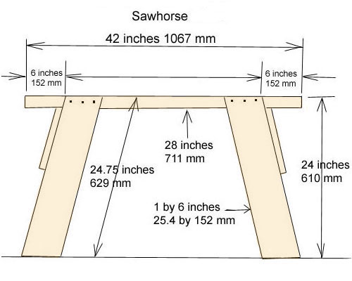
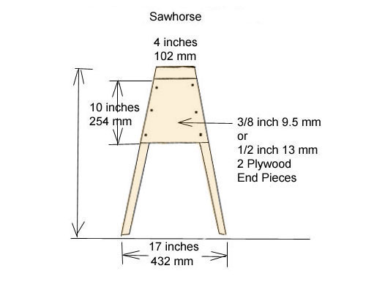

Sawhorse Leg Measurements

Use the Framing Square to lay out the sawhorse legs.
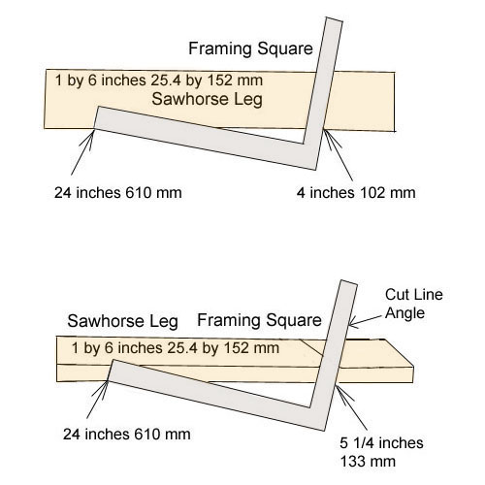
Place the framing square on the top surface of a 1 by 6 inch wooden board as shown in figure 3 top. The lay out can also be done with metric units. Set the blade at 24 inches and the tongue at 4 inches along the board's edge. Mark the top of the sawhorse leg along the tongue. Measure back 24.75 inches from the top of the leg and lay out the bottom of the leg with the same units. The sawhorse leg length is shown in figure 1. Repeat the procedure for all four legs.
- Use the framing square to lay out the cut angle along the top and bottom of the sawhorse
- Place the framing square along the edge of the board so that the tongue is set at 5 1/4 inches on the leg's top edge line, and the blade is set at 24 inches. Mark the cutting angle. Repeat the lay out at the bottom of the board and for all four sawhorse legs. Cut out the legs.

Sawhorse Top Piece Layout

- Mark a line 6 inches from each end of the sawhorse top piece.

Figure 4 Sawhorse Top Piece Layout
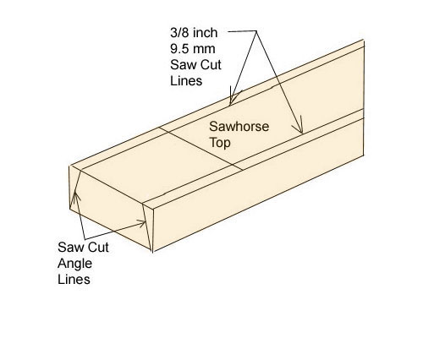
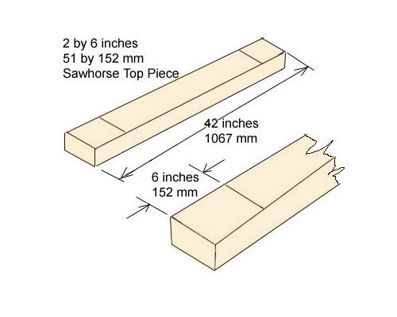

Draw two parallel lines, each 3/ 8 of an inch from a long edge, on the upper surface of the sawhorse top piece.
See figure 5. Draw saw cut angle
Position each sawhorse leg on the sloping surface .

Figure 5 Saw Cut Angle Lines On Sawhorse Top
Sawhorse Plywood End Piece

Make two plywood end pieces to brace the sawhorse legs. To make the first end piece, place a ten by twelve inch, 3/8 or 1/2 inch thick, piece of plywood on two of the sawhorse legs as shown in figure 6. Position the plywood against the bottom surface of the top piece and mark the location of the sawhorse legs on the plywood. Connect the marks and cut out the plywood end piece. Place the sawhorse on a level surface and tack the end piece to each leg with three or more 2 1/4 inch (57 mm) nails. The nails should be spaced no more than six inches apart. Undernailing can weaken the frame and overnailing can damage and weaken the wood. Adjust the end piece until the sawhorse stops wobbling and drive in the tacking nails. Repeat the procedure with the other end piece and legs.

Students' Shop-built project Rubric

POINTS | 10 | 8 | 6 | 4 | 0
Measurements | Pieces cut to correct size, free of chips & dents. All pieces are correct. | Some pieces are incorrect. Pieces cut to within 1/8". One or two chips or dents.. | More than 3 pieces incorrect. Pieces cut to within 3/16". Few chips & dents. | Pieces are missing or falling off. Seems "slapped together" in a hurry. Measurements over 1/4" off. | Did not compete project.
Structure | All parts are assembled in a sound manner. All joints glued properly. Screws and nails in appropriate locations. | Most parts are assembled in a sound manner. Most joints glued properly, including fasteners. | Some parts are assembled in a sound manner. Some joints glued properly. Fasteners not accurate | Project is poorly assembled and is un-sound. | Project is un-assembled and in pieces, or unfinished.
Finish | Wood is sanded to a smooth finish with no burn or tool marks Finish is smooth, no drips, even color, no gouges. | Wood sanded, 1-2 burn marks, few visible tool or sanding marks, no runs or drips in finish. | Some sanding, visible tool marks over more than 20% of surface, uneven color, finish coats not applied evenly. 3-5 burn or tool marks and runs. | Gouges, tool marks and imperfections not sanded. color very uneven or not applied, finish has runs and drips and uneven spots. | No finish applied.
Overall Appearance | Free of pencil marks, scratches, dents. Free of planer marks & cross grain sanding marks. Free of dust specks, brush bristles, runs, sags. Dry smooth uniform finish. Very nice piece. | Free of pencil marks, No scratches or dents. Free of planer marks with few cross grain sanding marks. Few dust specks, No brush bristles. One run or sag. Dry smooth uniform finish. Nice Piece. | One or two pencil marks. Few scratches or dents. One or two planer marks with few cross grain sanding marks. Few dust specks, No brush bristles. Few run s or sags. Dry uniform finish. Satisfactory. | Project is very messy with runs and drips on finish there were not enough finish applied. Un-Satisfactory. | Project is not finished
Use of Class Time | Class time was used wisely. Much time and effort went into planning, design, and construction. Student was always working or helping others with their project, never found not working. | Class time was used wisely. Time and effort went into planning, design, and construction. Student worked well on own project but did not help others. | Class time was not always used wisely. Sometimes found not working. | Class time was not used wisely. Often found not working. | Class time was used to visit and create problems.

Students' Written-Instructions Rubric
Points
 | 10 Points | 8 Points | 6 Points | 5 Points
Audience | Instructions | Instructions | Audience is not | No attention
 | make it clear who | include some | clear, and | to directing
 | should and | acknowledgement | instructions | instructions to
 | should not use | of who the | seem very | a specific
 | these instructions | audience is and | general and | audience.
 | and how the | their needs for | vague.
 | instructions will | using these
 | meet audience’s | instructions.
 | needs.
Purpose | Purpose of | Purpose is | Purpose is not | No attention
 | instructions is | somewhat clear, | clear at all. | to purpose of
 | very clear and | but not outlined | Document just | document.
 | audience knows | well for the | starts with
 | what they will be | audience. May | instructions and
 | able to do after | include a weak | no purpose
 | reading the | introduction and | clarification.
 | document. | incomplete table
 | Includes an | of contents.
 | introduction and
 | table of contents.
Use of Images | Well-labeled | Well-labeled | Some pictures | No pictures
 | pictures | pictures | are included | are included in
 | accompany the | accompany the | with the | the
 | instructions. The | instructions. | instructions, but | instructions.
 | images make the |  | they are not | The document
 | instructions clear |  | clear, well- | includes text
 | and easy to |  | labeled, or | only.
 | follow. |  | connected to
 |  |  | the text.
Visual Design | Instructions are | Instructions are | Instructions are | Instructions
 | very well | well-organized | organized into | are poorly
 | organized into | into major | sections. | organized or
 | major sections | sections that are |  | have no clear
 | with clear labels | labeled. |  | organization
 | and a table of |  |  | at all.
 | contents.
Completeness | Instructions | Instructions | Instructions | Instructions
 | include all | include | may be missing | are
 | necessary | information | some steps or | incomplete
 | information and | needed to | the steps are | and offer no
 | pictures, | complete the | not clear. | help for the
 | including any | task. |  | user.
 | contact
 | information for
 | help and
 | troubleshooting.

